

COURSE: | ARTIFICIAL INTELLIGENCE
LAB: | # 12
NAME: | MUZAMMIL BIN SOHAIL
ROLL NO.: | 22F - 3110
DEGREE: | BS - AI
SECTION: | 4A1

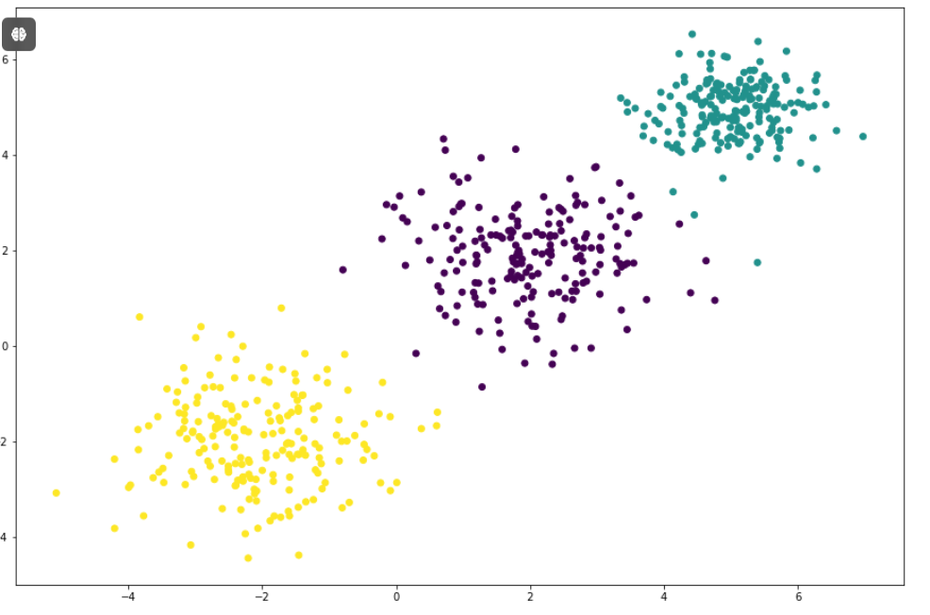
import random
import math

def kmeans(X,k=3,max_iterations=100):
'''
X: multidimensional data
k: number of clusters
max_iterations: number of repetitions before clusters are established

Steps:
1. Convert data to numpy aray
2. Pick indices of k random point without replacement
3. Find class (P) of each data point using euclidean distance
4. Stop when max_iteration are reached of P matrix doesn't change

Return:
np.array: containg class of each data point
'''
"""
IMPLEMENT THE CODE FOR K Means Implementaion From Scratch

"""

p1 = random.randint(0, len(X)-1)
c1 = (df[0][p1], df[1][p1])

p2 = random.randint(0, len(X)-1)
c2 = (df[0][p2], df[1][p2])

p3 = random.randint(0, len(X)-1)
c3 = (df[0][p3], df[1][p3])

print(p1)
print(p2)
print(p3)

print(c1)
print(c2)
print(c3)

for i in range(0, 100):
cluster1 = []
cluster2 = []
cluster3 = []
print(len(X))
for j in range(0, len(X)):
if(j == p1 or j == p2 or j == p3):
break
else:

#d1 is the distance of that point in the iteration from the centroid 1
d1 = math.ceil(abs(df[0][j] - c1[0]) + abs(df[1][j] - c1[1]))
d2 = math.ceil(abs(df[0][j] - c2[0]) + abs(df[1][j] - c2[1]))
d3 = math.ceil(abs(df[0][j] - c3[0]) + abs(df[1][j] - c3[1]))
#print(d1)
#print(d2)
#print(d3)

if(d1 <= d2 and d1 <= d3):
cluster1.append([df[0][j], df[1][j]])

elif(d2<= d1 and d2<= d3):
cluster2.append([df[0][j], df[1][j]])

else:
cluster3.append([df[0][j], df[1][j]])

cluster1.append(c1)
cluster2.append(c2)
cluster3.append(c3)

print(len(cluster1))
print(len(cluster2))
print(len(cluster3))

xOfNewCentroid1 = 0
yOfNewCentroid1 = 0

sumX1 = 0
sumY1 = 0
for i in cluster1:
if(i != c1 and i != c2 and i!= c3):
sumX1 = sumX1 + i[0]

if(i != c1 and i != c2 and i!= c3):
sumY1 = sumY1 + i[1]

xOfNewCentroid1 = math.ceil(sumX1/(len(cluster1)))
yOfNewCentroid1 = math.ceil(sumY1/(len(cluster1)))

xOfNewCentroid2 = 0
yOfNewCentroid2 = 0

sumX2 = 0
sumY2 = 0
for i in cluster2:
if(i != c1 and i != c2 and i!= c3):
sumX2 = sumX2 + i[0]

if(i != c1 and i != c2 and i!= c3):
sumY2 = sumY2 + i[1]

xOfNewCentroid2 = math.ceil(sumX2/(len(cluster2)))
yOfNewCentroid2 = math.ceil(sumY2/(len(cluster2)))

xOfNewCentroid3 = 0
yOfNewCentroid3 = 0

sumX3 = 0
sumY3 = 0
for i in cluster3:
if(i != c1 and i != c2 and i!= c3):
sumX3 = sumX3 + i[0]

if(i != c1 and i != c2 and i!= c3):
sumY3 = sumY3 + i[1]

xOfNewCentroid3 = math.ceil(sumX3/(len(cluster3)))
yOfNewCentroid3 = math.ceil(sumY3/(len(cluster3)))

if(c1 == (xOfNewCentroid1,yOfNewCentroid1) and c2 == (xOfNewCentroid2,yOfNewCentroid2) and c3 == (xOfNewCentroid3,yOfNewCentroid3)):
print("THIS IS THE POINT OF CONVERGENCE")
break

c1 = (xOfNewCentroid1,yOfNewCentroid1)
c2 = (xOfNewCentroid2,yOfNewCentroid2)
c3 = (xOfNewCentroid3,yOfNewCentroid3)
break

P = c1 + c2 + c3

return P

